**Table of Contents**

**Abstract**

**Acknowledgement**

**Chapter 1 Introduction**

**1.1 Purpose**

**1.2 Scope**

**1.3 Project Overview**

**Chapter -2: Project Management**

**2.1 Project Planning**

**2.1.1 Project Development Approach and Justification**

**2.1.2 Roles and Responsibilities**

**2.2 Project Scheduling (Gantt Chart)**

**Chapter -3: System Requirement Study**

**3.1. User Characteristics (Type of users who is dealing with the system)**

**3.2 Hardware and Software Requirements (minimum requirements to run your**

**system)**

**Chapter -4: System Analysis**

**4.1 Study of Current System**

**4.2 Problem and Weaknesses of Current System**

**4.3 Requirements of New System**

**4.3.1 Functional Requirement**

**4.3.2 Non Functional Requirements**

**4.4 Data Modelling**

**4.4.1 E/R Diagram**

**4.5 List Main Modules of New System Conclusion**

**4.6 Flow diagram/Flow Chart**

**Chapter – 5: System Design**

**Chapter – 6: Conclusion and Discussion**

**CHAPTER 1-INTRODUCTION**

This particular project deals with the problems on managing a hostel and avoids the problems which occur when carried manually. It reduces the manual work of management. It secures the data of the students. We can improve the efficiency of the system, thus overcome the drawbacks of the existing system. It enhances the reputation of the educational institute.

### **Purpose of Project**

* + The main purpose of our website is to ease the task of people who are sometimes confused about deciding which place to visit and an e-ticket (electronic ticket) is a paperless electronic document used for ticketing.
  + It can help in better crowd management of museums/heritage sites. It reduces booking expenses by eliminating the need for printing and mailing paper documents.
  + Can help in keeping a better record of visitors.
  + Can improve sales as a visitor can book, purchase and print out the electronic ticket any time 24 hours a day."

### **1.2** **Scope of Project**

* Scope of our website is for the people who are enthusiastic about visiting and exploring various famous places of Gujarat.
* Saving the time of the people as they don’t have to stand in long queue for getting the tickets.
* As a result they result they can explore more destinations in less time.
  1. **Project Overview**
* The proposed system is designed in HTML, javascript and css. The back end of the project is developed using PHP and MySQL. The project is a web application that has similar functionality to either a desktop software application or a mobile application.The project aims to do an online booking system is to allow potential customers to self-book and pay through your website, securely store customer's data, and It can book the ticket of various famous places of Gujarat.

**CHAPTER 2-PROJECT MANAGEMENT**

### **Project Planning**

**2.1.1 Project Development Approach and Justification**

Discovery & Planning. This phase is the foundation upon which the entire project is planned and developed before building a website.

* Design & UI Coding.
* Development.
* Quality Control.
* User Acceptance Testing.
* Our project justifies all the above approaches because we have proper time management as well as work management.

### **2.1.2 Project Effort and Time Estimation**

* Our project requires the effort to make the website pages creative so that it must attractive to the visitor’s of the website as well as for the connection of the database.
* Approximate time required is 4 months.

### **Roles and Responsibilities**

* Providing smooth communication between the Parents and the Wardens
* Prioritizing the project requirements and tasks
* Estimating the time
* Reporting on progress
* Tracking the work hours
* Creating a favourable atmosphere in the team
* Making sure the user’s expectations are met
* Maintaining the documentation

**Project Scheduling (Gantt Chart/PERT/Network Chart)**

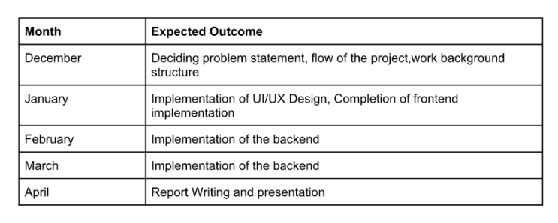

**CHAPTER 3 – REQUIREMENT STUDY**

### **3.1 User Characteristics (Type of users who is dealing with the system)**

* + - Our website is mainly used by tourists or people who want to book tickets easily in online mode and who want information about what place to visit and how to visit it.

### **Hardware and Software Requirements (minimum requirements to run your system)**

**Hardware Interfaces**

Windows and a browser which supports CSS, HTML, JavaScript.

**Software Interfaces**

**Software used and its function:**

**Operating system:** We have chosen Windows operating System for its best support and user-friendliness.

**Visual Studio Code:** To implement the project we have chosen HTML, CSS, JavaScript language for its more interactive support

### **Assumptions and Dependencies**

* The fundamental premise of this project is that the user will have access to enough information about this website and to evaluate our offering, use the maximum resources provided by us.

**CHAPTER 4 – SYSTEM ANALYSIS**

### **Study of Current System**

* Our current system deals with the solving of problems.It provides some of the advantage like
* No need of taking print out.
* You are becoming environment friendly and contributing for greener planet by ignoring printout.
* While booking counter ticket you had to carry cash and while booking E- ticket you are paying through online directly from bank which makes work more easy for you.
* Online ticket booking systems clearly bring about tons of benefits for an enterprise, especially in the Fourth Industrial Revolution.

### **Problem and Weaknesses of Current System**

* There are a lot of drawbacks in keeping, maintaining and handling the Website.When you book online, you usually can’t ask a live person questions about that place, routes, visa requirements or anything else you’re concerned about. You may not be able to confirm special requests at the time of your online reservation.Many online travel sites advertise low rates to attract your attention and then add fees and surcharges for a much less competitive deal.

### **Requirements of New System**

* The proposed system is a web based application and maintains a centralized repository of all related information. The system allows one to easily access the relevant information and make necessary travel arrangements. Users can decide about places they want to visit and make bookings online for travel and accommodation.

### **Functional Requirements**

* In software and system engineering, a functional requirement defines a function of a system or its components, where a function is described as a specification of behavior between outputs and inputs.
* Booking confirmation should be sent to user to the specified
* contact details.
* The admin can delete or update any ticket.
* The admin can view the information about any ticket.

### **4.2.2** **Non Functional Requirements**

* Database Security: An unauthorized person cannot access the panel and database, do not read and write the information. It should maintain the security of the client’s payment method.
* Reliability Requirement: Travel management system should provide a reliable environment to both customers and owner.Admin should be able to upload delete update new packages without any error.
* Usability Requirement: The travel Management System in PHP is designed for user friendly environment and ease of use.
  1. **Features Of New System**

### Clean, Easy-to-Use, and User-friendly

* Responsive Design
* Database Security

* 1. **Flow Diagram**

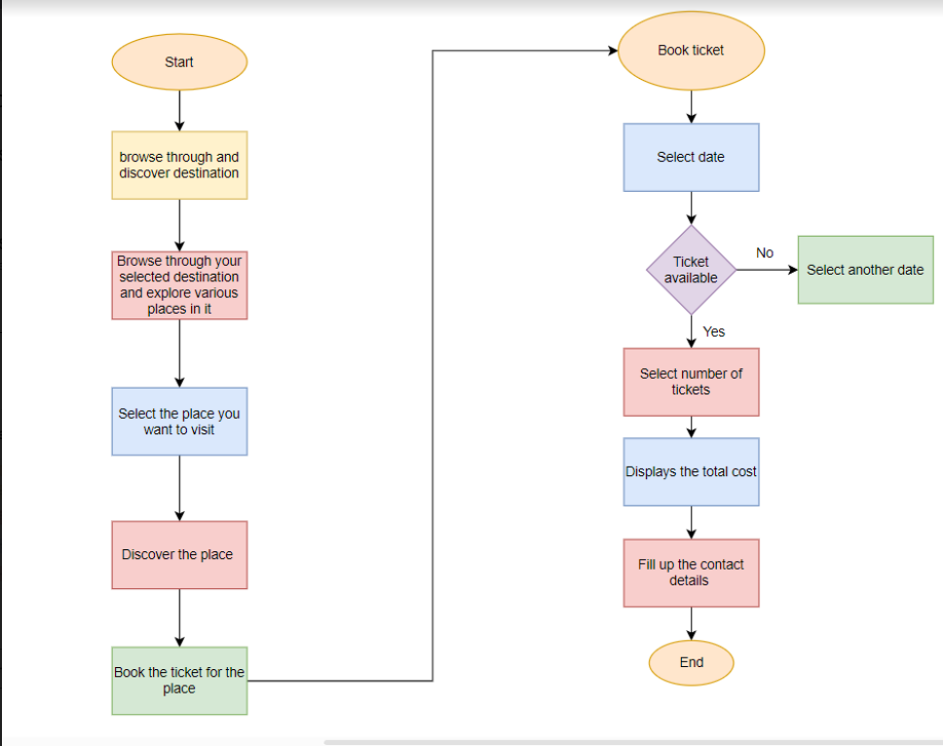

**CHAPTER 5 – SYSTEM DESIGN**

**Home-page:**

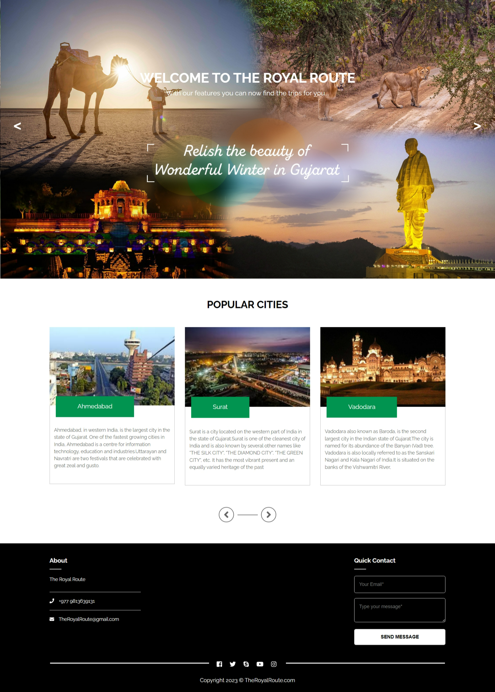

**City Pages:**

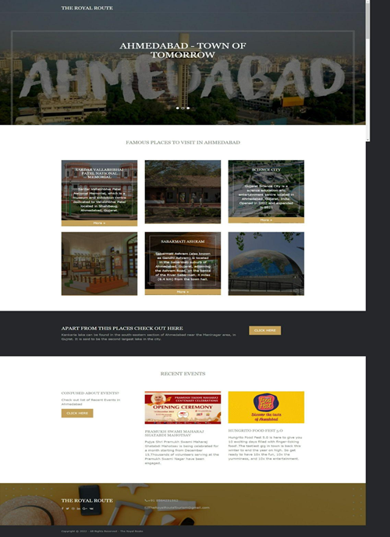

**City Pages:**

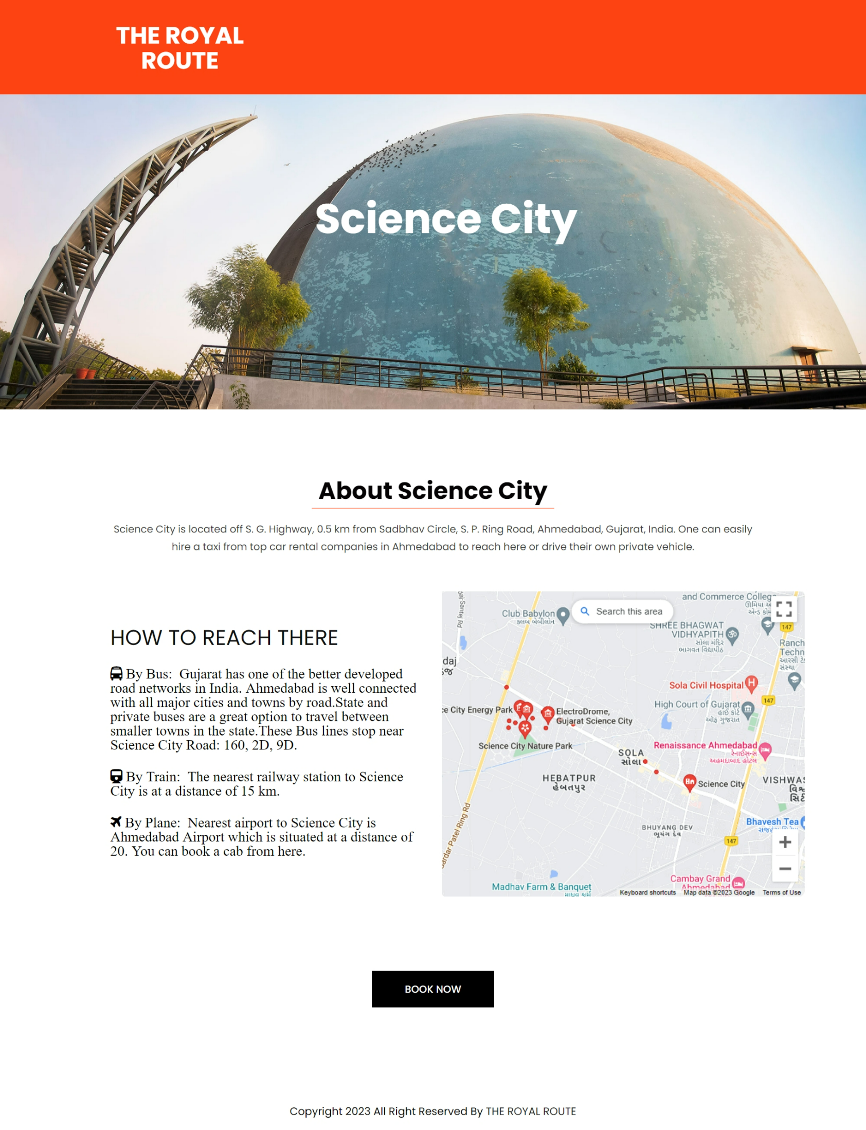

**Ticket Reservation :**

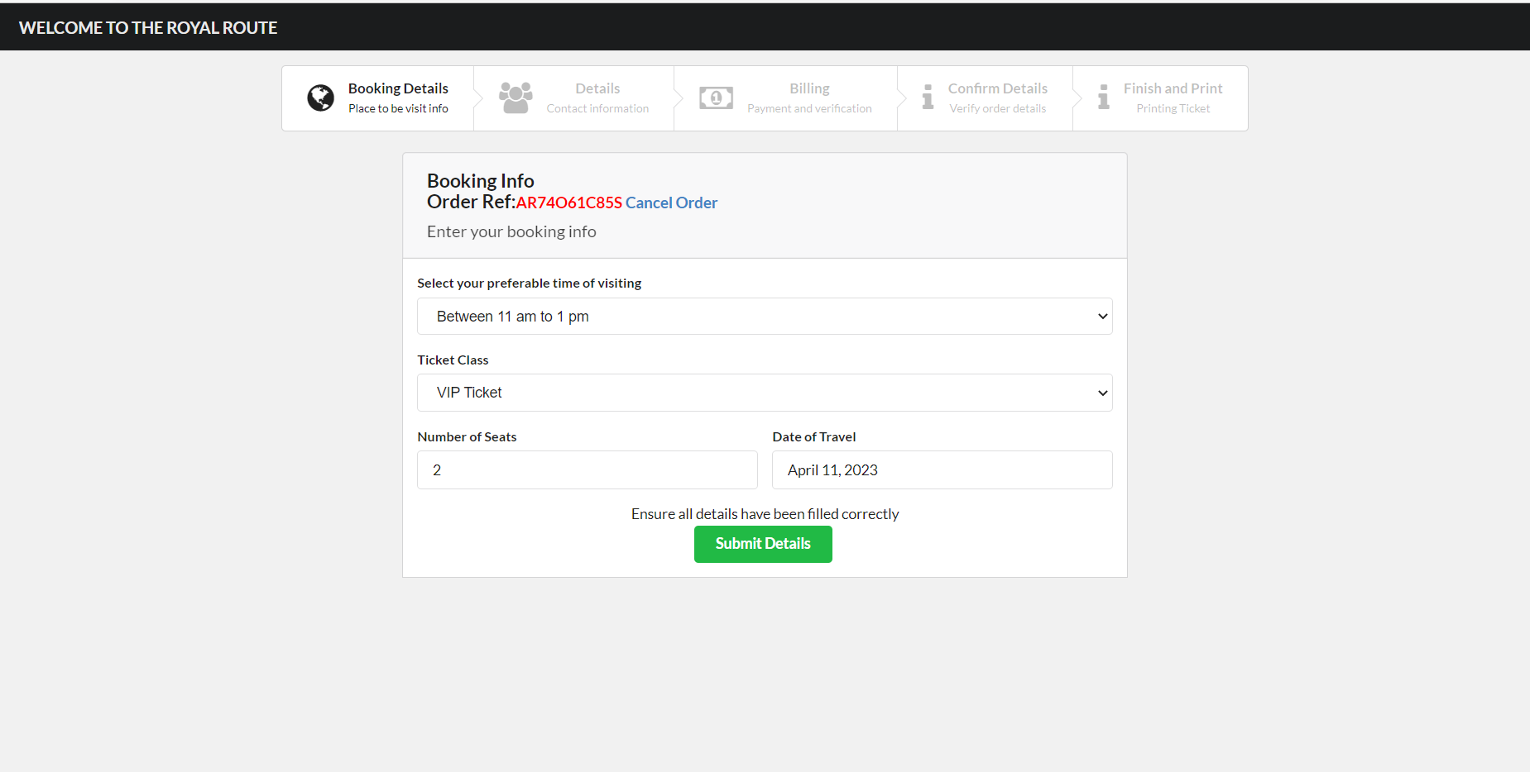

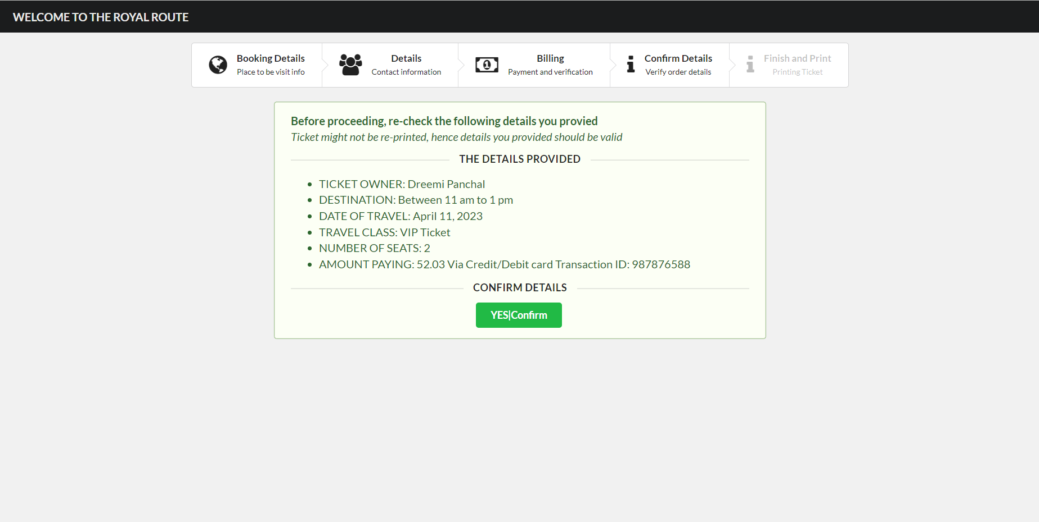

# **6.0 Conclusion and Discussion**

Our project is a very helpful and important project that will help help a lot of people and ease the process of ticket booking. Another benefit of this project is that it will save a lot of time of standing in queue for booking a ticket.This system will also be able to show the records of ticket booked and all its relevant information.

# **Limitation and Future Enhancement:**

* Limitation of the project is that everyone must have the knowledge of using the modern technology and have the access to internet .
* Future enhancement of the project is that by the time we will implement the payment gateway and try to make it more dynamic and user friendly